3rd Party Developer Tools

Installation Guide

Document Version: 8.3
January 2026

1. Introduction 3
1.1. Terms and Conditions 3
2. Components & Tools 4
3. Requirements 5
4. Local Test Service (LTS) 6
4.1. Install 6
4.2. Configure 6
4.3. Run 6
4.4. Usage 7
4.5. Static/Fixed Responses 7
4.6. Testing 8
5. LTS Update Manager (LTSUM) 9
5.1. Install 9
5.2. Basic Configuration 10
5.3. Proxy Server Configuration 10
5.4. Run 10
6. LTS Injector (Injector / Batch Processor) 11
6.1. Install 11
6.2. Configure 11
6.3. Run 11
6.4. Usage 11
7. SOAP Messages 12
8. Download and use the Artefacts without using Update Manager. 13
8.1. How to Manually Download RIM Artefacts 13
8.2. Configuration 14
9. Frequently Asked Questions (FAQ) 16

Introduction
HMRC has traditionally supported third party developers primarily through its TPVS (Third Party Validation Service) environment. This does, however, require developers to wait for the TPVS release slots for functionality to be delivered. This will still continue, but there is a requirement to be more agile and deliver services earlier if possible. To this end, a number of downloadable applications have been developed that should support more frequent releases of code and business rules to third party developers.

These tools are supported by the Software Developer Support Team (SDST):

Email: sdsteam@hmrc.gov.uk

Terms and Conditions
This should be read in conjunction with the HMRC Disclaimer and Privacy Policy on the HMRC web site.
The HMRC External Software Proving Services listed below in Section 2, Components and Tools, are provided ‘as is’ without any representation or endorsement made and without warranty of any kind whether express or implied, including but not limited to the implied warranties of satisfactory quality, fitness for a particular purpose, non-infringement, compatibility, security and accuracy.
We do not warrant that the functions contained in the material on this service will be uninterrupted or error free, that defects will be corrected, or that this site or the servers that make it available are free of viruses or represent the full functionality, accuracy or reliability of the materials. In no event will HMRC be liable for any loss or damage, or any loss or damages whatsoever arising from the use, or loss of use, of data, or profits arising out of or in connection with the use of the HMRC External Software Proving Services.
HMRC offers a local test service containing machine readable rules and calculations for some services, the use of the machine-readable rules and/or calculations by customers or developers within their own products is permissible but is undertaken entirely at their own risk.
By accessing these services or making use of the machine-readable rules and calculations therein, you are accepting these terms and conditions.

Components & Tools
There are currently three tools available for developers:

- Local Test Service (LTS)
  - A standalone application for validating XML submissions against the relevant XML schema and business rules.

- LTS Update Manager (LTS-UM)
  - A support tool used to download and install service packs for use in the LTS.

- LTS Injector (Injector / Batch Processor)
  - A tool for sequentially submitting XML documents to the LTS for validation.

Detailed instructions on how to install, configure and run each of these components can be found in the following sections.

Requirements
A working Java Software Development Kit (SDK) needs to be installed and working on machines where any of the applications are to be run. This should be at least version 11, but ideally the latest long term support release, which is version 21 at the time of writing. Java is available to download at https://www.oracle.com/uk/java/technologies/downloads/

Note that a Java Runtime Environment (JRE) on its own is not sufficient; you need to install an Java Development Kit.

Once installed, the JAVA_HOME environment variable should be set to the home directory of Java as illustrated in the following examples:

Windows
set JAVA_HOME=C:\Java\jdk21.0.4+7

Linux/UNIX/Mac (bourne/bash shell)
Export JAVA_HOME=/opt/java/jdk21.0.4+7

UNIX C Shell (csh and tcsh) Global Environment Variable
setenv JAVA_HOME=/opt/java/jdk21.0.4+7

This should then be included in the PATH environment variable so that Java can be run from any location.

The user that will be running the application(s) should be able to open a command prompt or shell window and type the following:

java –version

That should result in something similar to the following:

java version “21.0.4” 2024-07-16 LTS
Java SE Runtime Environment (build 21.0.4+7-LTS)
Java HotSpot Client VM (build 24.0.4+7-LTS, mixed mode, sharing)

If the user gets a “Command not found” type error, Java is not installed correctly on the path, and the user needs to review the above steps.

Local Test Service (LTS)
This web application replicates most of the functionality found in the TPVS environment for various services. This includes schema validation, business rule validation and IR Mark checking (the Irmark algorithm is checked when an Irmark is provided, LTS does not enforce the inclusion of an Irmark). Support for the GovTalk protocol and attachment checking is not included. Note that this application is a framework, which is configured by the LTS Update Manager (LTS-UM) to support selected services; without configuration the LTS does not support any service “out-of-the-box”.

The first submission to the LTS will take a few seconds longer than subsequent submissions. This is a normal feature, common to many web-driven applications.

Install
Extract the entire contents of the ZIP file to any desired location, e.g. /opt; referred to hereafter as: [extraction path].

Configure
The following environment variable is a mandatory requirement of the LTS application (and also the LTS Update Manager tool):

- LTS_HOME - Absolute path to the LTS directory.
This should be equivalent to: [extraction path]/HMRCTools/LTS
E.g.

Windows
set LTS_HOME=C:\[extraction path]\HMRCTools\LTS

Linux/UNIX/Mac (bourne/bash shell)

LTS_HOME=/[extraction path]/HMRCTools/LTS;export LTS_HOME

UNIX C Shell (csh and tcsh) Global Environment Variable

setenv=/[extraction path]/HMRCTools/LTS

(Note: [extraction path] points to the LTS directory from root)

Optionally, modify the following XML configuration file as required (further instructions contained within the file):

[extraction path]/HMRCTools/LTS/resources/config/UserConfigurable/LTSConfig.xml

Run
Execute the following script:

Windows
C:\[extraction path]\HMRCTools\LTS\RunLTSStandalone.bat

Linux/UNIX/Mac
[extraction path]/HMRCTools/LTS/RunLTSStandalone.sh

Note: It will be necessary to assign the appropriate permissions for this file before attempting to execute it.
E.g. chmod 755 RunLTSStandalone.sh

Usage
There are FOUR ways in which to use the LTS:

- Single File Upload
Enter the following the URL into an Internet Browser and follow on-screen instructions to upload a single file:
http://localhost:5665/LTS

To upload a SOAP message for FS3, use the following URL:

http://localhost:5665/LTS/EMCS

For further lines of business, new upload screens may be developed. These are detailed in Appendix B.

- Batch Processing
Process multiple files at once using the LTS Injector tool. [See the LTS Injector section below for details].

- HTTP POST
HTTP POST to the following URL programmatically using application/x-binary mime type:
http://localhost:5665/LTS/LTSPostServlet

- SOAP Toolkit
It is possible to use a Soap Toolkit to hit the web services directly. Please see Section 8 for details.

Static/Fixed Responses
As the LTS is purely designed for use as a validation tool, providing an intelligent response based on the incoming request is not possible. The fixed responses provide a mechanism to test these scenarios as per the live environment. One example of this would be the need to respond to a request for multiple messages.

To provoke a fixed response, a key specified in the incoming message must match the filename of the fixed response (minus the file extension). For GovTalk messages, this is the Key element (both in the GovTalk header, and also the IRHeader). For SOAP messages this is the <Username> element in the security header.

For example, to get the fixed response of a user failing authentication in a SOAP message, the username must be “8901”. This relates to the file at location:
[extraction path]\LTS\resources\responses\Authentication\8901.xml

To aid a third-party developer, the LTS provides an easy way to provide your own fixed responses, so that the values within these responses can be tailored to be more specific to an individual user.
The fixed responses are all held within relevant folders at the following location:
[extraction path]\LTS\resources\responses\

To provide your own fixed response, create your xml file and save it to the directory which is relevant to your line of business and message type.

Then, in your incoming message, ensure the username in the header is the same value as the filename, e.g. for SOAP Messages: <Username>000001</Username>.

Provided the incoming message passes schema and business rule validation, the fixed response will be returned. A list of usernames that are preconfigured within the LTS are listed in Appendix A.

Testing
A test service is included by default in the initial installation of the LTS, called the RIM100 service. This can be used to prove the installation of the LTS by using one of the methods above to submit a RIM100 test file, found in the [extraction path]/HMRCTools/TestData directory.

LTS Update Manager (LTSUM)
This GUI application is used to manage the services installed into the LTS framework and the configuration file of the LTS itself. It also displays important notification messages, such as the release of new versions of the LTS components. The content displayed is available via HMRC servers.

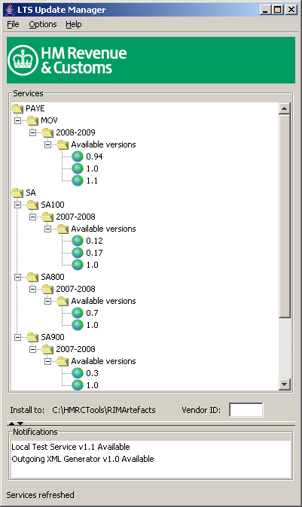

Install
This tool comes bundled within the LTS Application and is installed along with it as standard.

Basic Configuration
The following environment variable is a mandatory requirement of the LTS Update Manager tool (and also the LTS application):

- LTS_HOME - Absolute path to the LTS directory.
This should be equivalent to: [extraction path]/HMRCTools/LTS
E.g.

Windows
set LTS_HOME=C:\[extraction path]\HMRCTools\LTS

Linux/UNIX/Mac
Export LTS_HOME=/[extraction path]/HMRCTools/LTS

Proxy Server Configuration
It maybe necessary to use Update Manager via a Proxy Server. In most cases this is due to a client of the vendor’s internal network accessing the Internet via a proxy server for security / web caching purposes. To configure the Update Manager to point to the proxy choose: ‘Options’ → ‘Settings’ from the menu bar to reveal the following dialog:

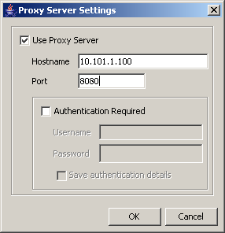

Check ‘Use Proxy Server’ and set the ‘Hostname’ and ‘Port’ of your proxy (sample shown). Some proxy servers may require authentication, check the ‘Authentication Required’ checkbox to enable the ‘Username’ and ‘Password’ fields. Click ‘OK’. This configuration is now set to use the proxy. The settings will be saved when exiting Update-Manager.

Run
Execute the following script:

Windows
C:\[extraction path]\HMRCTools\LTSUM\RunUpdateManager.bat

Linux/UNIX/Mac
[extraction path]/HMRCTools/LTSUM/RunUpdateManager.sh

Note: It will be necessary to assign the appropriate permissions for this file before attempting to execute it.
E.g. chmod 755 RunUpdateManager.sh

LTS Injector (Injector / Batch Processor)
Automates the process of uploading multiple XML submission files to the LTS.
Please note that the LTS Injector is unable to process SOAP messages.

Install
This tool comes bundled within the LTS Application and is installed along with it as standard. The LTS Injector has been designed to run under Windows only as an example of how a product can use the LTS for handling validation.

Configure
By default, this utility expects the following two directories to exist:
- [extraction path]/HMRCTools/LTS/InjectorUtility/source
  - XML submission files to upload to the LTS Application
- [extraction path]/HMRCTools/LTS/InjectorUtility/dest
  - XML result files returned by the LTS Application

The ‘Run’ script may be modified to specify alternate locations for either of these directories.

If the default configuration of the LTS has been changed to use a custom URL (hostname and/or port number), the ‘Run’ scripts must also be changed to reflect this.

Run
Execute the following script:

Windows
C:\[extraction path]\HMRCTools\LTS\InjectorUtility\RunInjectorUtility.bat

Usage
Place XML submission files in the source directory and then run the utility to upload ALL of the files to the LTS.

SOAP Messages
It is possible for a third-party developer to use a Soap Toolkit (such as Soap UI) to submit messages directly to the LTS web services.

The service names that are currently enabled for this are listed below:

EMCS (FS3 only)
http://localhost:5665/LTS/EMCS/AcknowledgeMessagesReceipt/4
http://localhost:5665/LTS/EMCS/GetMovementForTrader/4
http://localhost:5665/LTS/EMCS/GetNewMessages/4
http://localhost:5665/LTS/EMCS/SubmitReportofReceipt/4
http://localhost:5665/LTS/EMCS/SubmitExplainDelayToDelivery/4
http://localhost:5665/LTS/EMCS/SubmitCancellation/3
http://localhost:5665/LTS/EMCS/SubmitChangeOfDestination/3
http://localhost:5665/LTS/EMCS/SubmitDraftMovement/3
http://localhost:5665/LTS/EMCS/SubmitSplitMovement/2
http://localhost:5665/LTS/EMCS/SubmitAlertOrRejectionMovement/2
http://localhost:5665/LTS/EMCS/SubmitReasonForShortage/2

Download and use the Artefacts without using Update Manager.
Versions of LTS prior to 8.0 can no longer connect to the Update Manager. This is because of advances in transport layer security that mean old Java 7 applications can no longer establish secure connections to HMRC’s website.

The recommended action is to upgrade to LTS 8.0 or above and upgrade from Java 7 to Java 21. However, if you are unable to do this and need to continue to use Java 7 and versions of LTS older than 8.0, then there are a few steps that can be followed to download the RIM Artefacts without the need to use the Update Manager.

How to Manually Download RIM Artefacts
After completing the configuration step (Section 4.2):
The URLs to download the Artefacts for all the services can be found in :
https://www.tpvs.hmrc.gov.uk/tools/v2/services.xml

The below example is for SA100 Artefacts and Calc.
E.g., the highlighted URL in the below excerpt can be used to download SA100 Artefacts for 24-25
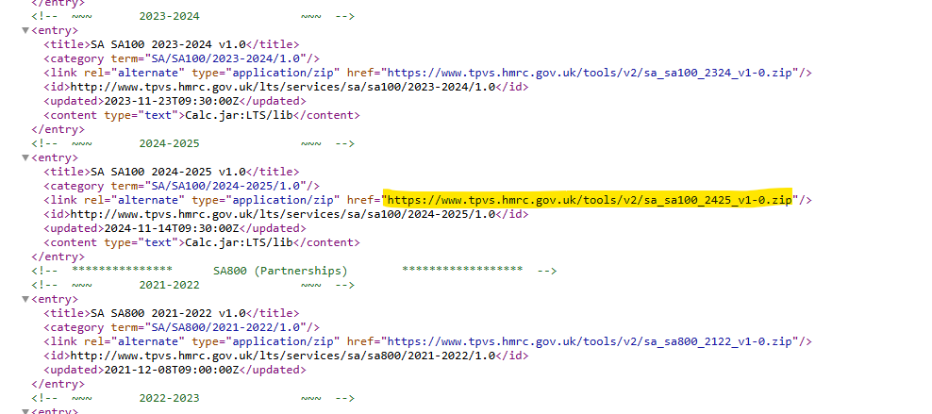
In this example, the “<title>” tag indicates that the entry is for SA100 2024-2025, and the “href” for this artefact points to https://www.tpvs.hmrc.gov.uk/tools/v2/sa_sa100_2425_v1-0.zip This is the artefact that you would need to download manually.
Next:
-Under [extraction path]\HMRCTools \RIMArtefacts
-Create the directory SA
-Create the subdirectories as in the path SA100\2024-2025\1.0
- Extract the downloaded zip (sa_sa100_2425_v1-0.zip) to that directory.
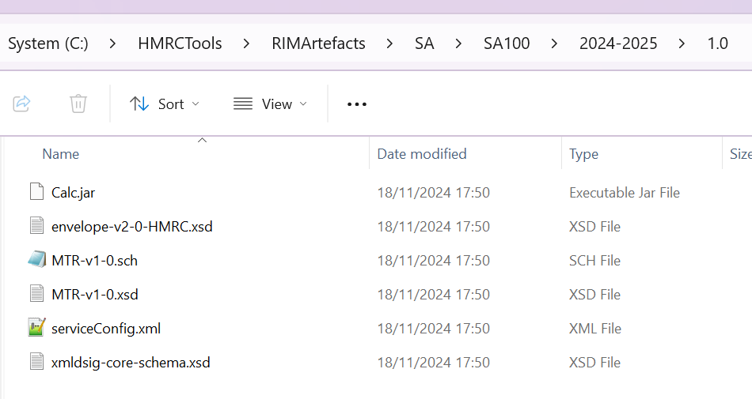

-Specific For Services that use Calc:
Replace the Calc.jar in
[extraction path]\HMRCTools \LTS\lib
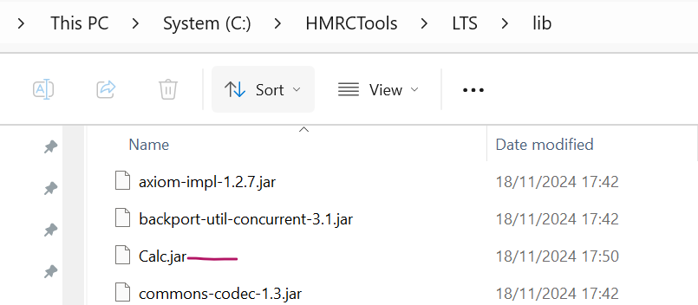
with the one from
[extraction path]\HMRCTools\RIMArtefacts\SA\SA100\2024-2025\1.0

If there is no Calc.jar file in the RIM Artefact that you’ve downloaded then you can leave the existing Calc.jar file in the “lib” folder.

Configuration
- Update the file :
[extraction path]\HMRCTools\LTS\resources\config\NonConfigurable\validatorConfig.xml
By adding the <Service> items.
To configure the service, the namespace for the service and the location for the RIMArtefacts (The extracted file from section 9.1) for that service are needed. The namespace for the service can be found in the schema files inside the extracted Artefacts file as “targetNamespace” attribute .
The example below is for <Service> items for SA100:
<Service uri="http://www.govtalk.gov.uk/taxation/SA/SA100/24-25/1">
<TotalErrorCap>100</TotalErrorCap>
<ValidationType>COMPLETE</ValidationType>
<RIMArtefactsDirectory>SA\SA100\2024-2025\1.0</RIMArtefactsDirectory>
</Service>

As in the screenshot below:
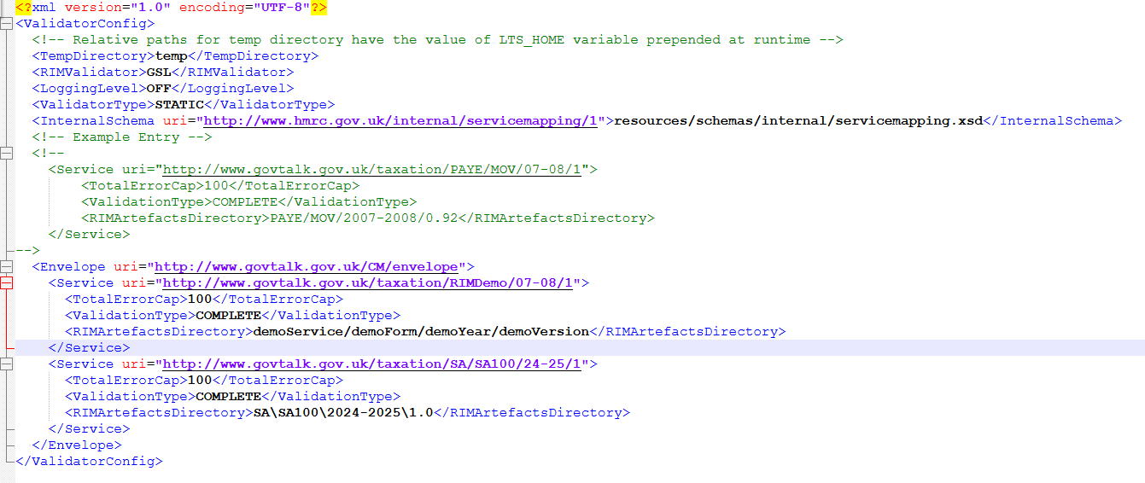

To run the tests, follow the steps in the sections (4.3).

Frequently Asked Questions (FAQ)
The instructions in this document should provide all the information required to get the LTS and its related components up and running. However, if guidance is required on a specific task or problem then this FAQ provides a quick reference for most of the common issues.

Contents

- How to configure the hostname and/or port number used to access the LTS.

- What configuration options exist for the validation engine?

- Error message: “You Must set the LTS_HOME environment variable, please consult the Install guide”

- Error message: “Exception in thread “main” java.lang.NoClassDefFoundError: xxxx”

- Error message: “Could not find the main class: xxxx. Program will exit”

- How would I configure the JVM to allow submission of large uncompressed messages.

1. How to configure the hostname and/or port number used to access the LTS.

This is configured within the following file:

[extraction path]/HMRCTools/LTS/resources/config/UserConfigurable/LTSConfig.xml

Instructions for modifying this configuration file are given within the file itself.

After changing the default configuration of the hostname or port number, if you wish to use the Injector Utility it will be necessary to update its configuration to reflect these changes. This involves modifying the Windows ‘Run’ script for the Injector Utility to use the new hostname/port details.

Within this Run script you will find two java commands. The first one starts the Injector Utility using the default URL for the LTS (http://localhost:5665/LTS). The second, which is commented out, provides an example of how you can specify a custom hostname and/or port number as a command line argument.

2. What configuration options exist for the validation engine?

The LTS Update Manager manages ALL of the configuration for the validation engine. No part of the validatorConfig.xml file should be modified manually.

If you wish to make changes to the validation engine (i.e. the rules used to validate against) then you must use the LTS Update Manager to perform these changes. Manual configuration is not supported and is likely to cause unexpected results.

3. Error message: “You Must set the LTS_HOME environment variable, please consult the Install guide”

The LTS application and the LTS-UM tool both require that an environment variable with the name LTS_HOME exist and be correctly configured with the absolute pathname of the LTS directory.

The value of this environment variable should be equal to the following:

[extraction path]/HMRCTools/LTS

If this is not the case then you will experience problems when trying to use the LTS or LTS-UM.

4. Error message: “Exception in thread “main” java.lang.NoClassDefFoundError: xxxx”

This error may occur when attempting to start the LTS application. The reason for this is because the LTS_HOME environment variable has been assigned a value that contains spaces but the value has not been wrapped in quotes ( “…” ).

To confirm this, you should recognise some or all of the “xxxx” section of the message as being part of the LTS_HOME value.

To rectify the problem, re-assign the LTS_HOME environment variable such that its value is enclosed in quotes.

5. Error message: “Could not find the main class: xxxx. Program will exit”

This is the very same issue as detailed in number 4 above, except this error occurs when attempting to start the LTS Update Manager tool.

This error appears within a popup box, rather than in the command window.

6. How would I configure the JVM to allow submission of large uncompressed messages.

For large submissions, there may be an issue, where the LTS application may hang indefinitely
or may return and display a Stack Dump error ‘JVM out of Memory’.
In such situations, it may be necessary, to increase the Java Virtual Memory (JVM) setting for the LTS Application.
This is achieved by :-

- Stop the LTS Application server
- Open the RunLTSStandalone.bat file, located in the C:\HMRCTools\LTS Folder.
- Find the line, SET JAVA_OPTIONS=%JAVA_OPTIONS% -Xms128m –Xmx256m.
The –Xms128m parameter indicates that LTS will start with a minimum of 128M of memory.
The –Xmx256m parameter indicates that LTS will scale to a maximum limit of 256M of memory.
- Increase the –Xmx parameter setting according to specific requirements.
- Start the LTS Application server.
- If the submission processes, return the –Xmx parameter setting to its original setting of 128M of memory, or continue to increase the –Xmx parameter setting, accordingly.

NOTE : In general there is a 23M limit in LTS on Uncompressed Submission file size.

Appendix A – Preconfigured Usernames for fixed responses

EMCS Messages
AcknowledgeMessagesReceipt:
8901 – Authentication failed

GetMovementForTrader:
8901 – Authentication failed
000001 – Movement ARC does not exist.
000002 – Movement found.
000003 – Movement found (where multiple versions exist).

GetNewMessages:
8901 – Authentication failed
000001 – No Messages found for this trader.
000002 – Messages found (where there are no more messages to download).
000003 – Messages found (where there are more messages to download).
000004 – ie704 response for ie818
000005 – ie704 response for ie837

SubmitExplainDelayToDelivery:
8901 – Authentication failed

SubmitReportofReceipt:
8901 – Authentication failed

SubmitReasonForShortage:
8901 – Authentication failed

EMCS FS3 Specific Messages
PreValidateTrader
8901 – Authentication failed
000001 – Pre-validation request with valid trader and product code(s)
000002 – Pre-validation request with invalid trader and no product code(s)

Appendix B – Specific Line of Business functionality

NA.

Appendix C – Document Control

Version | Date | Comments
3.0 | 15/07/2011 | Changes for August 2011 release.  RTINOT tab added to OXG.
3.1 | 21/10/2011 | Item added to FAQ section.
3.2 | 06/06/2012 | Remove FS0 & FS1 refs. Add SubmitReasonforShortage details.
3.3 | 15/10/2012 | Include FAQ 6.
5.0 | 22/07/2014 | Java 7 upgrade
5.2 | 31/10/2014 | SA rules plus Charities rules
5.6 | 26/09/2018 | Remove SubmitSplitMovement(IE825) and changed FS3 to MDG001
5.9 | 05/02/2020 | Reverted the MDG001 to FS3.4
6.0 | 09/12/2020 | SA rules YOY
6.1 | 18/08/2021 | RTI level 3 validation changes.
6.2 | 19/11/2021 | SA Annual Changes 21/22
6.3 | 27/01/2022 | ESEF Taxonomy Intercept
6.4 | 27/06/2022 | PR011173 AIC049131 Decommissioning of TPVS PAYE EOY-LTS- Removed PAYE EOY section.
6.5 | 27/10/2022 | PR011606 SA NTY 22-23 AIC100690
6.6 | 07/10/2022 | PR011197 AIC051025 REQ001093 ChRIS FS4.0 changes
6.7 | 22/02/2023 | EIS TS2 PR010563 EIS_6522 CR004 2023 COTAX Changes Post
6.8 | 28/11/2023 | PR013239 ChRIS Development including Core Filing for 23-24
6.9 | 17/01/2024 | EMCS FS4 Changes
7.0 | 25/11/2024 | PR014136 ChRIS Development including Core Filing for 24-25 Added section 9: Download and use the Artefacts without using Update Manager  Note added to section 5.4
8.0 | 01/04/2025 | Updated in light of migration to support Java 21.  Removed references to no-longer-supplied OXG component.
8.1 | 22/04/2025 | New Calc-20250304 amd SA900 V1-1 for SA24-25
8.2 | 10/11/2025 | New Calc-20251015 and COTAX changes, EIS_25088 v2 PRO14926
8.3 | 15/01/2026 | PR015039 REQ016802 CBP , ODS, OTRSA and ChRIS including corefiling

